**OpenMP**

[OpenMP](http://openmp.org/wp/) (<http://www.openmp.org/>) enables parallel computing on single computer by taking advantage of the multiple cores shipped on modern CPUs .

**Windows**

1. Go to <http://tdm-gcc.tdragon.net/>. Download TDM_GCC.

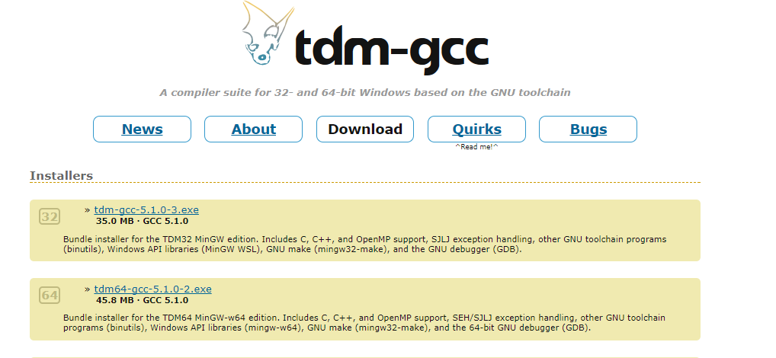

2. Uncheck the box “Check for updated files on the TDM-GCC server” and click “Create”.

3. Click “Next” to see the installation setup. Check the box “openmp” under “gcc”.

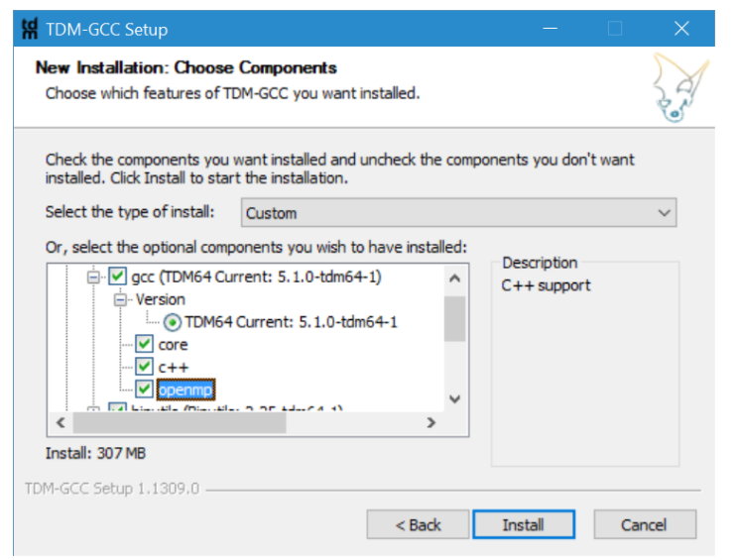

4. Now, you can use gcc -fopenmp to run OpenMP on you PC.

**Mac OS X**

Please refer to the following webpage for the installation OpenMP on Mac, depending on the R version and the complier your mac uses.

https://cran.r-project.org/bin/macosx/

http://thecoatlessprofessor.com/programming/openmp-in-r-on-os-x/